Franchisee Fitness Para Todos: Franchise Agreements

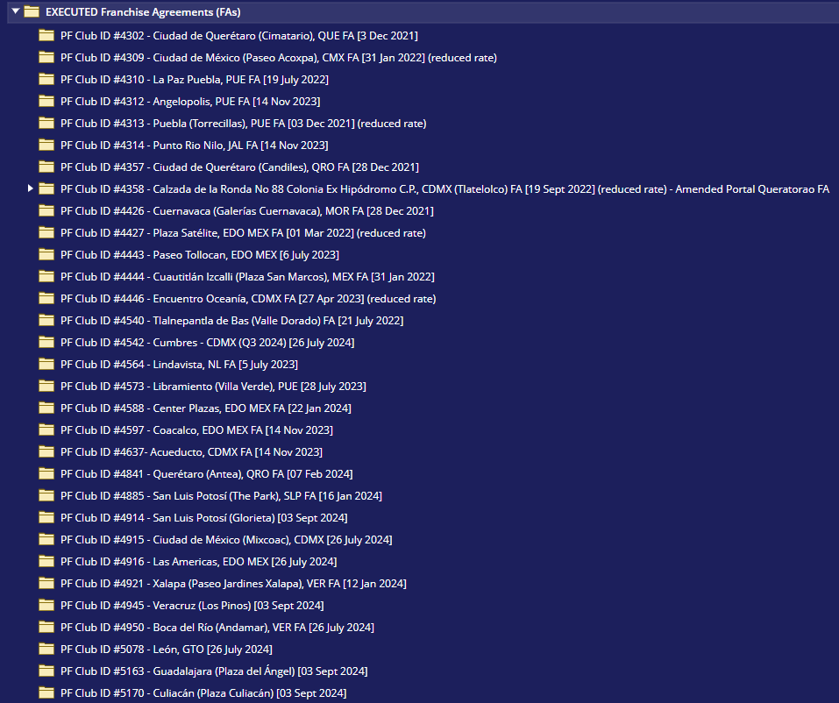

Franchisee: JEG-Mexico Bueno: Monterrey Clubs: Franchise Agreements and Acquisition Amendments to each FA

